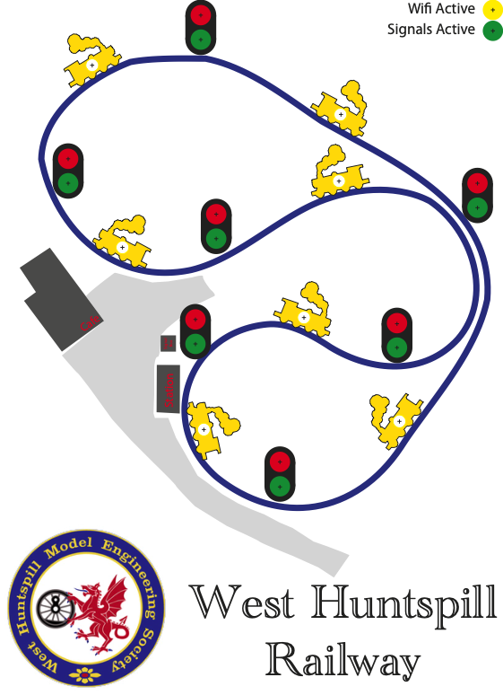

Signalling

Signal Box Module 3

Power Supply 4

Controls 4

Indicators 5

Typical construction 6

Indicators 6

Operation 7

Emergency Stop 7

Clear Track 8

Demo Mode 8

Sensor Module 9

Power Supply 10

Signal Connections 12

Stop button 12

Address 12

Local Jumpers 14

Train Sensor setup 16

TP-Link Exterior WiFi 18

Information 18

Figure 1 top view of the signal box pcb 3

Figure 2 power connection 4

Figure 3 switch connections 5

Figure 4 Typical face plate design 6

Figure 5 indicators attached to ribbon cable 7

Figure 6 Indicator detail 8

Figure 7 Sensor module 9

Figure 8 Power connection 10

Figure 9 Location of protection diode 11

Figure 10 Signal light connectors 12

Figure 11 Address switch 13

Figure 12 Local configuration jumpers 14

Figure 13 Sensor setup method 16

Figure 14 Sensor adjustment screws and sensor active LED 17

## Signal Box Module

The signal box module is the main controller for the signals around the track. It has two modes of operation, master and slave.

Master mode enables the main processing of the signal box. Messages are received from the sensor modules and the appropriate light changes determined. The light status is then sent to all the sensor modules. In master mode the signal box module can support up to 16 signals.

Slave mode permits the addition of extra track display units showing the location of trains and the state of the signals. When in slave mode the signal box displays the status of the signals and track sections. The number of slave signal box modules is essentially unlimited. Total devices on the network is limited to 200 units.

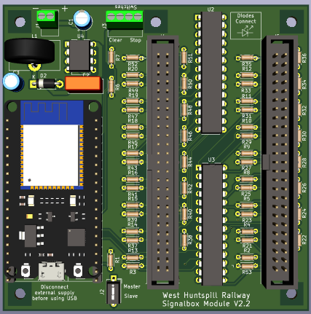

Figure top view of the signal box pcb

### Power Supply

The signal box module runs from a DC power supply with a voltage between 6 and 24V with a maximum power draw of 1W. Power is connected to the 2 pin screw terminal (J1) on the PCB. Care must be taken to connect the power supply with the correct polarity. Failure to do so can result in damage to the module.

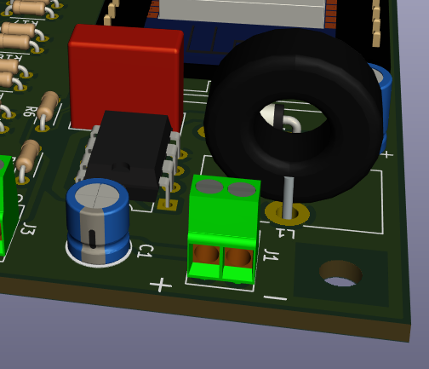

Figure power connection

### Controls

The signal box module is equipped with two connections for switches to control the signals on the track. Buttons are connected to the 4 pin screw terminal (J3) on the PCB. A “Stop” button, typically a latching button, is used to turn all signals to RED. This would typically be used in an emergency stop situation. A “Clear” button, usually a momentary button, is used to clear all the yellow trains from the track. This is used to clear a “Ghost Train” from a track section if for example it has been removed at the transfer area.

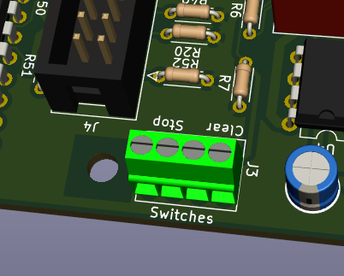

Figure switch connections

### Indicators

The signal box module has up to 16 red and green LEDs representing the signals on the track. These are matched by up to 16 yellow LEDs indicating an occupied section of track. There is also a yellow “WiFi Active” LED indicating that the signal box module is connected to WiFi and a green “Signals Active” LED indicating that the signal box module is connected to sensor modules and actively controlling the signals. When in Demo mode the Active LED flashes. When in Slave mode the Active LED remains off.

### Typical construction

The typical construction for a signal box module consists of a printed face plate showing the layout and position of the signals with the train LEDs spaced between the signals

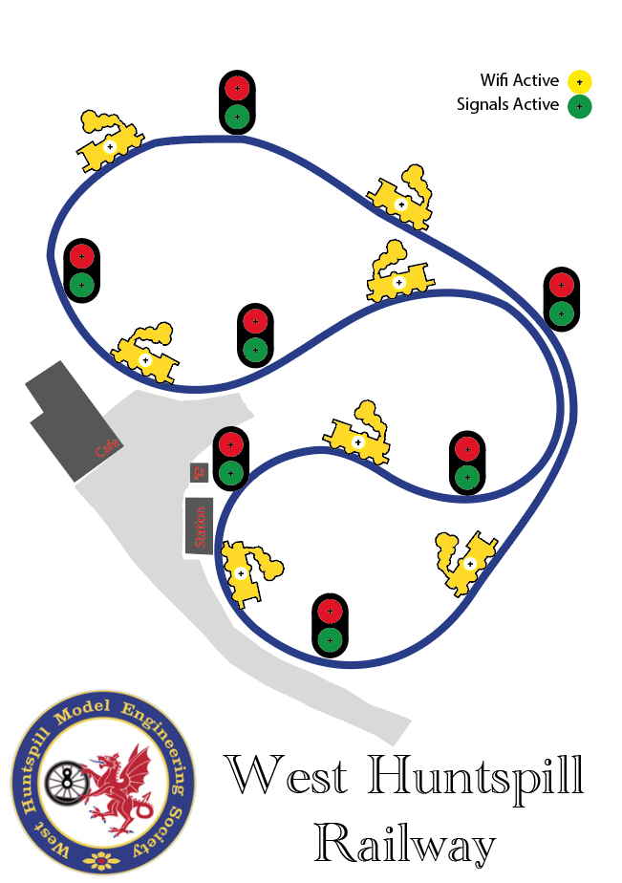

Figure Typical face plate design

The LEDs are connected via ribbon cable to the signal box module.

### Indicators

The LEDs are connected in groups of three starting at trace one of the ribbon cable. The LED colour sequence is GREEN, RED, YELLOW. The final LED on J4 is YELLOW for the WiFi indication and the final LED on J5 is GREEN for the active indication (note making the WiFi and active LED the same colour would permit a standard cable construction)

The Cathode (+’ve) of the LED connects to the first wire and the Anode (-‘ve) to the next wire in the cable.

The first six traces of the ribbon cable connected to J4 have the indicators for the first track section 0. The first six traces of the ribbon cable connected to J5 have the indicators for section 8.

Populate as many indicators as required for the signals deployed on the track. Fully populating the ribbon cables and leaving the unused indicators inside the signal box case permits simple addition of extra signals indicators in the future.

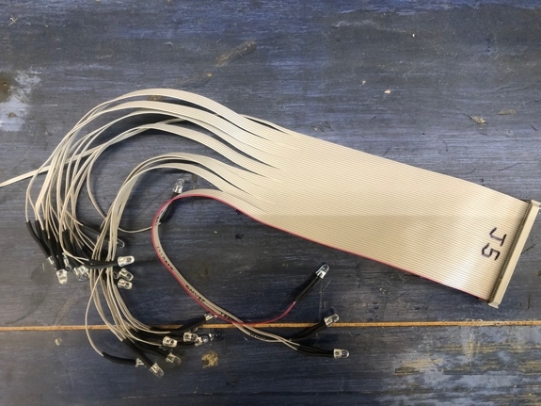

Figure indicators attached to ribbon cable

### Operation

Power on the signal box module. The WiFi active LED indicator will light when the WiFi is connected. Note: The WiFi can be provided by one of the sensor modules (selectable via jumper on the sensor module). This is suitable for small deployments only and limited to six active devices on the network. For larger layouts an external WiFi network is required. Once WiFi is connected the signal box will listen for sensors to connect. When one or more sensors has connected the signal box module will enter active mode and start controlling the signals. The signals active indicator will light.

Any inactive sensors will be ignored and operation will continue with only the active signals.

It is possible to simply turn the power on for all the sensors and signal box modules to start the signals working.

### Emergency Stop

Press the Stop button and all the signals will be set to RED. Release the Stop button and automatic mode will resume. Any trains that have moved while the Stop mode is enabled will be indicated in their new positions once the Stop button is release.

### Clear Track

Pressing the clear button will remove all the yellow track occupied indicators from the board. Red signals (blocking access to previously occupied track) will remain RED and may be cleared by pressing and releasing the Stop button momentarily.

### Demo Mode

The sensor module has a demo/test mode. This simulates a train travelling around the track switching signals to red and making track occupied. Slave signal box modules and the signals will also indicate the simulated train travel.

Demo mode is started by pressing the stop button and the clear button when the master signal box module is powered on. Hold the clear button down as the train advances around the track until it reaches the final section (when Signal 6 goes red in the example below). Release the clear button to let the signal box know how many sections are included in the demo. The demo mode will continue with the train looping around the track until the stop button is released. When the stop button is released the signal box will enter the normal operating mode.



Figure Indicator detail

## Sensor Module

The sensor module provides multiple functions and great flexibility in layout and use. The sensor module uses an ultra-sonic range sensor to detect the presence of a train. The sensor has a maximum range of 4m and a sensor beam width of 15 degrees. The sensor should be positioned such that a train travelling along the track passes through the ultra-sonic beam. The sensor range is adjustable to eliminate false detection such as from a person walking between the track and the sensor or along the outside of the track.

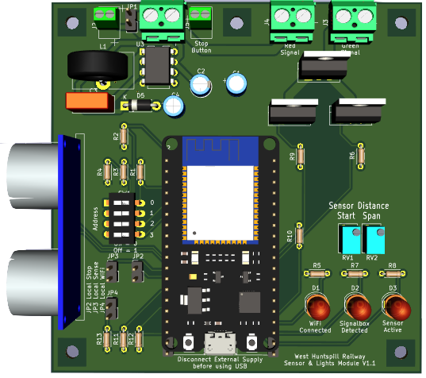

Figure Sensor module

The sensor module supports a stop button that can be used to turn the signal to red manually. This permits the control of the signal by the station master or steaming bay manager to control departure of trains from the station or to prevent access to the transfer area when trains are being staged. There are two high current capable outputs for connection to the signal lights. The sensor modules are also capable of providing the WiFi network for the system.

### Power Supply

The sensor module has flexible power supply options. It is possible to use different power supplies for the module and the signal lights. This provides more options of lights types, including the possibility of switching motors or solenoids to control functions such as gates, barriers or bells.

If a single supply is to be used a jumper is connected to JP1 and power connected to J1

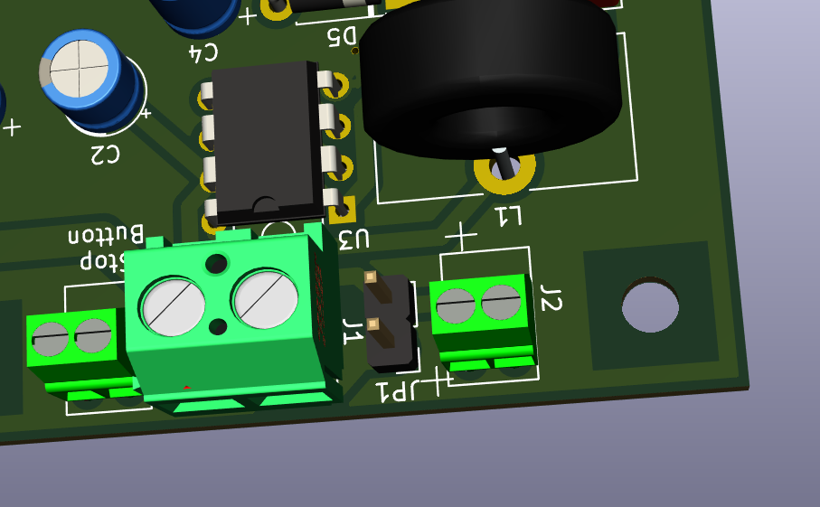

Figure Power connection

#### Board Power

Connector J2 is used for board power and supports voltages of 6 to 24V DC. Care must be taken to ensure correct polarity of the power connection. Incorrect connection can damage the sensor module.

#### Signal Power

Connector J1 is used for the signal lights power and supports voltages from 6 to 60V. The sensor module switches can handle 50A maximum but require additional heat sinks for currents over 10A. If inductive loads (motors, solenoids, relays etc) are connect then the protection diode D4 (DSSK50-01A) must be fitted.

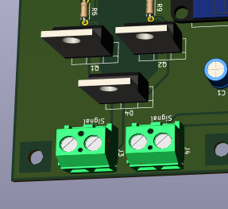

Figure Location of protection diode

Important! If JP1 is fitted the signal power must not exceed 24V or damage to the sensor module will occur.

### Signal Connections

The signal lights are connected to J3 (green) and J4 (red). If LED lights are used ensure the polarity of connection is correct.

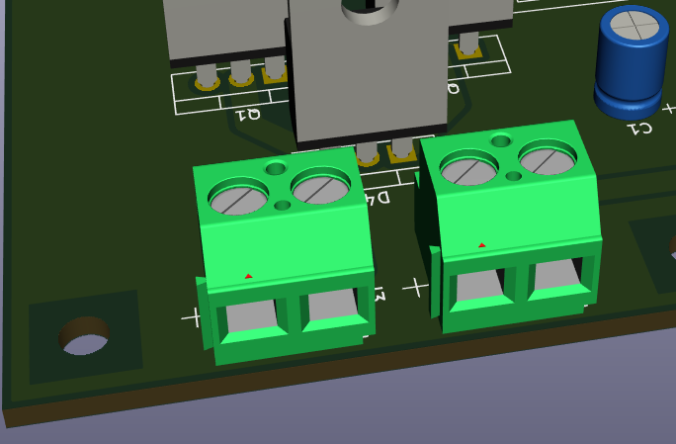

Figure Signal light connectors

### Stop button

An optional stop button can be connected to the sensor module. This permits the manual control of the signal from the signal location. A typical use is at the station where a stop button can be used by the station master to control the departure of trains. Wire connections to the stop button should be limited in length to ensure reliability. As a rule of thumb 10m should be OK. In the case where the stop button needs to be at a greater distance (possibly at the transfer area) an additional sensor module can be used as a remote stop button Configuration

#### Address

Each sensor module needs to be assigned an address. This corresponds to its position in the signal sequence around the track, see *Figure 6 Indicator detail* for a typical addressing sequence for a track.

Addresses are set using SW1

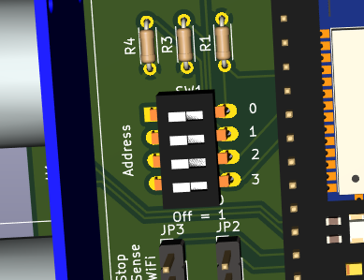

Figure Address switch showing set to address 15

The following table shows the switch settings for all possible addresses.

|  |  |  |  |  |
| --- | --- | --- | --- | --- |
| Sensor | SW1-0 | SW1-1 | SW1-2 | SW1-3 |
| 0 | ON | ON | ON | ON |
| 1 | OFF | ON | ON | ON |
| 2 | ON | OFF | ON | ON |
| 3 | OFF | OFF | ON | ON |
| 4 | ON | ON | OFF | ON |
| 5 | OFF | ON | OFF | ON |
| 6 | ON | OFF | OFF | ON |
| 7 | OFF | OFF | OFF | ON |
| 8 | ON | ON | ON | OFF |
| 9 | OFF | ON | ON | OFF |
| 10 | ON | OFF | ON | OFF |
| 11 | OFF | OFF | ON | OFF |
| 12 | ON | ON | OFF | OFF |
| 13 | OFF | ON | OFF | OFF |
| 14 | ON | OFF | OFF | OFF |
| 15 | OFF | OFF | OFF | OFF |

When using multiple sensor modules for a single section of track set all the modules to the same address

### Local Jumpers

The three local jumpers permit configuration of the board characteristics.

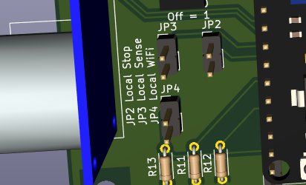

Figure Local configuration jumpers

#### Local WiFi

When JP4 is shorted the sensor module will create a WiFi network for the signals. Only one sensor module, usually the one closest to the centre of the area, is configured to provide the WiFi network.

Note: Local WiFi only supports six connected devices. For larger networks of devices and external WiFi device is required.

#### Local Stop

JP2 is used to configure the operation of the stop switch. When the jumper is not fitted the presence of a train on the track is determined by the train sensor. When JP2 is shorted releasing the stop switch will force clear the track. Typical use of the forced clear option is at the Steaming Bay where trains are removed from the track. Releasing the stop button will clear the track and set the signals to green. Alternatively at the Station, configured without the short, releasing the stop button will cause the red signal to flash if a train is still occupying the track after the light. This lets the station master know that he/she has released the stop but it is not safe for the train to depart.

Note: an additional sensor module can be used to support the stop button. The signal light switching will also function on the additional module enabling local tally lights to be connected to the remote sensor module. This is useful if the main signal lights are not visible from the stop button location.

#### Local Sense

JP3 is used to disable the sensor distance settings on the board. When shorted the sensor will take the sensor range settings sent by the signal box. This permits the use of the WHRDisplay application to configure the sensor settings.

### Train Sensor setup

The ultra-sonic train sensor can be configured to avoid false detection. Two adjustment screws are provided.

RV1 is used to set the minimum detection distance. RV2 sets the span of the detection range.

Alternatively the WHRDisplay application can be used with the sensor configured for remote settings.

To adjust the range position a board between the train sensor and the track so that the board is a few centimetres closer to the sensor than any part of the train will travel. The widest part of the train is likely the legs of the driver or passengers.



Figure Sensor setup method

Turn the sensor screw until the sensor active LED on the sensor module lights up. You might need to wind the screw fully one way then reverse the direction to find the detection point. Fully anti clock wise is the minimum distance. 10 full turns are required to go from end to end of the adjustment.

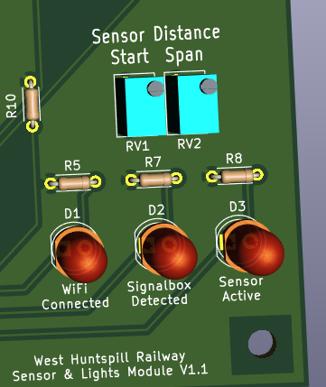

Figure Sensor adjustment screws and sensor active LED

Reposition the board to the outside of the track and adjust the span screw until the sensor active LED just changes state.

Check the settings are correct by moving the board from the sensor position to the far side of the track and watch the sensor active LED. It should light when the board is positioned anywhere where the train is expected to travel. Walk through the sensor beam on both the inside and outside of the track to ensure that the sensor does not trigger.

Note: The sensor only registers the closest thing to the sensor. If a person or other object is blocking the path between the sensor and the track the sensor will not activate when a train passes.

#### WHRDisplay application

An iPhone, iPad and macOS application is available which displays the current track light status and displays the messages sent by the sensor modules. When adjustments to the distance are made these can be seen on the application.

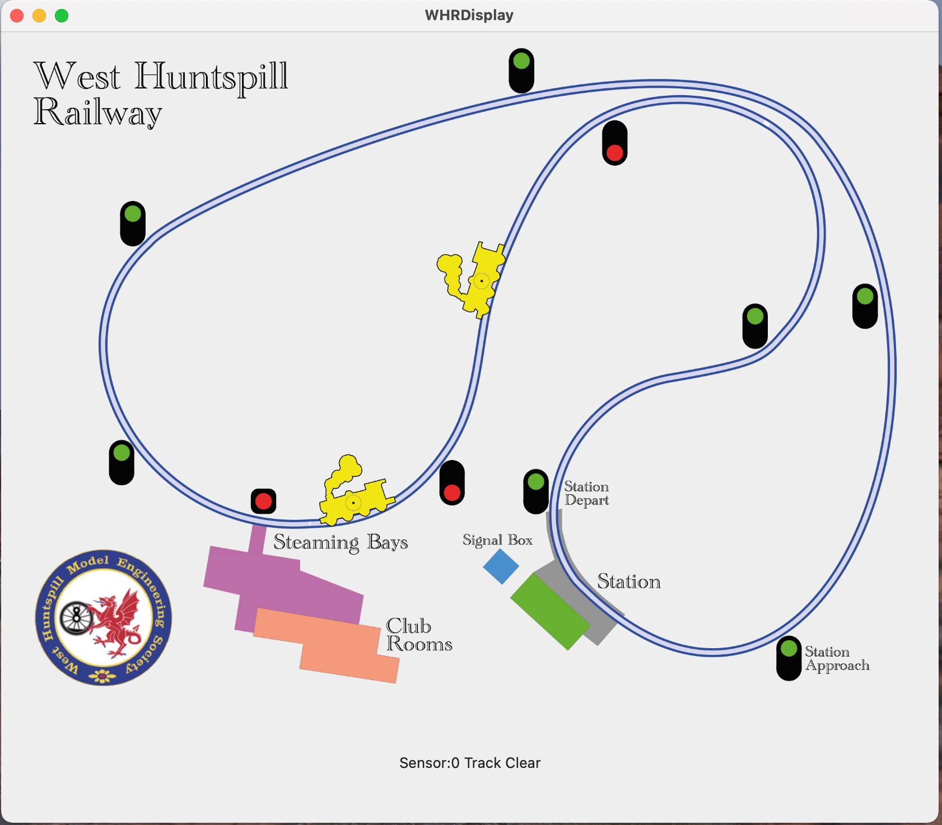

Figure WHRDisplay application

## TP-Link Exterior WiFi

For full coverage of the WHR site an external WiFi device is provided. This is based on a TP-Link Omada Outdoor access point. The outdoor part should be mounted on the roof of the signal box or at some other convenient location. Coverage area is an approximately 200m radius. The unit has an indoor box that provides power and the network connectivity. Note: the indoor unit is a custom device built using the TP-Link power over ethernet adaptor and the main board from an GL-iNet Smart router, together with a 5V power supply. The indoor unit is installed in a 3D printed box.

The indoor unit should be located close to a Mains 240V supply. An ethernet cable connects the indoor and outdoor units. Ethernet cables up to 100m are supported.

Plugging a 4G or 5G USB dongle or smart phone supporting tethering in to the side of the indoor unit can enable the provision of wide area network connectivity for the site. This might be useful at a future date. If required at any time please contact Paul Barnard to configure a public access SSID for the network.

## Information

The source code and PCB layouts (KiCAD) for the project are available on GitHub

<https://github.com/paulrbarnard/West-Huntspill-Railway.git>

The PCB are laid out for ESP32 DevKitC V4. Full parts list and UK based supplier information is contained in the PCB design documents.

The ESP board will be damaged if the USB is connected at the same time as the board power supply. The board power supply must be disconnected before using the USB to program the ESP32. The ESP32DevKit devices are socketed and can be removed from the main PCB for reprogramming to eliminate the need to disconnect wiring on site.